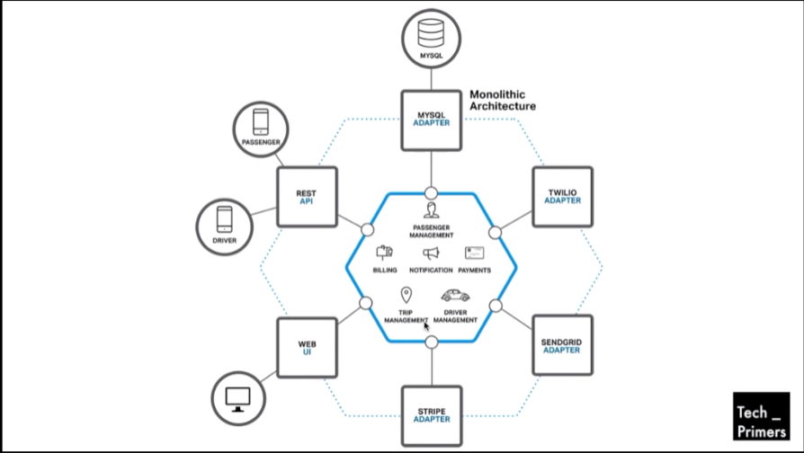

All Calls through API Gate Way.

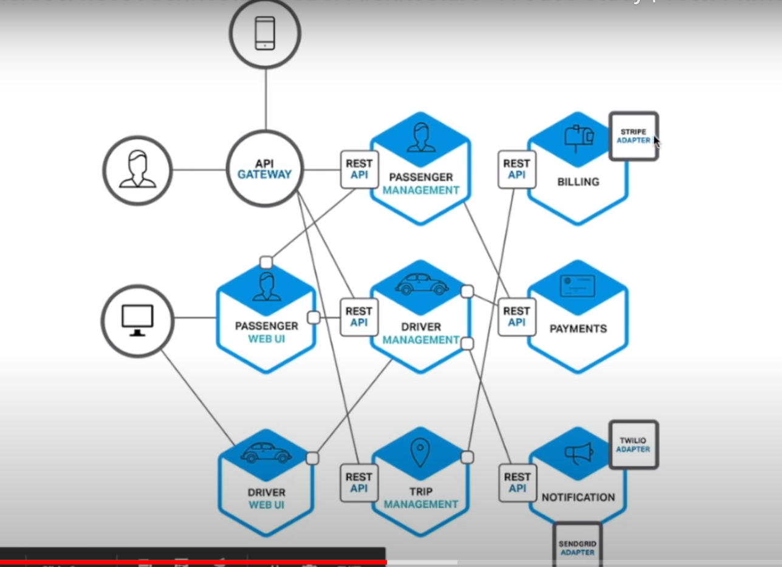

1. Points to remember
2. Go whenever scalable
3. Make it Resilience
4. Make individual component deployed into single server